For the general “font family” of all pages make it “ARIAL”

Meat Establishment Account

Summary for the receiving, Fit for Slaughter, Fit for human Consumption

Resolved: August 23, 2022

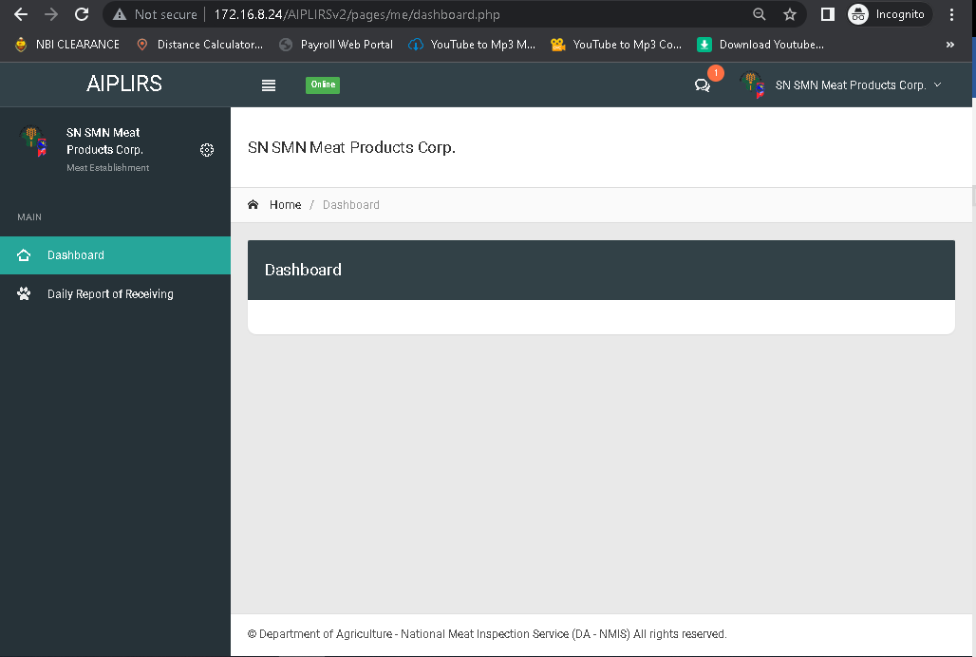

Change sidebar header and navigationbar header to “Receiving of Animals”

Resolved: August 23, 2022

Receiving of Animals: create active dropdown: add new transaction, List of transaction

Resolved: August 09, 2022

Add a summary for the me receiving,fit for slaughter, fhc

For the header of reports “Summary of Meat Inspection Report”

Resolved: August 23, 2022

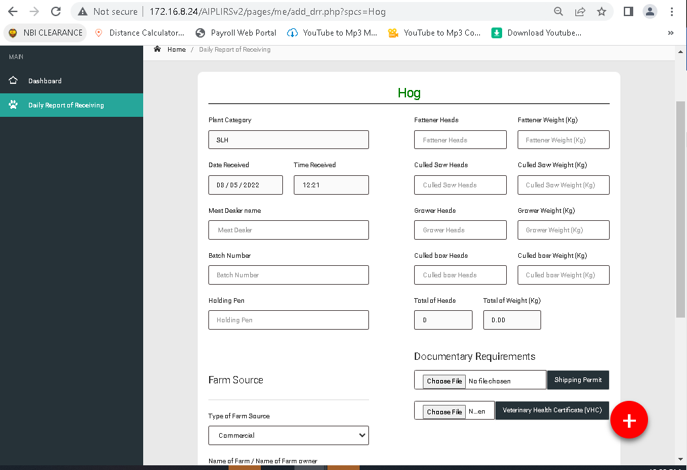

For the label of the input of category of food animals

Heads to head count

Weight to live weight(kg)

For the placeholder of the category of food animal make it 0 and holding pen

Choos file button make center reduce margin bottom

Batch number must be auto generated reset by month day batch number (format: mm-dd-batch number)

Meat Dealer name: change to Name of meat dealer on meat dealer input create a template for name standards, on registration lastname, firstname.

Plant Category remove

Remove break line and the spacing of the farm source spacing top

Total Heads to total head count

Total Weight to total live weight(kg)

Plus sign change to “submit” add pop up alert “Are you sure you want to submit your report? “ on pop up add button “Yes” “No”

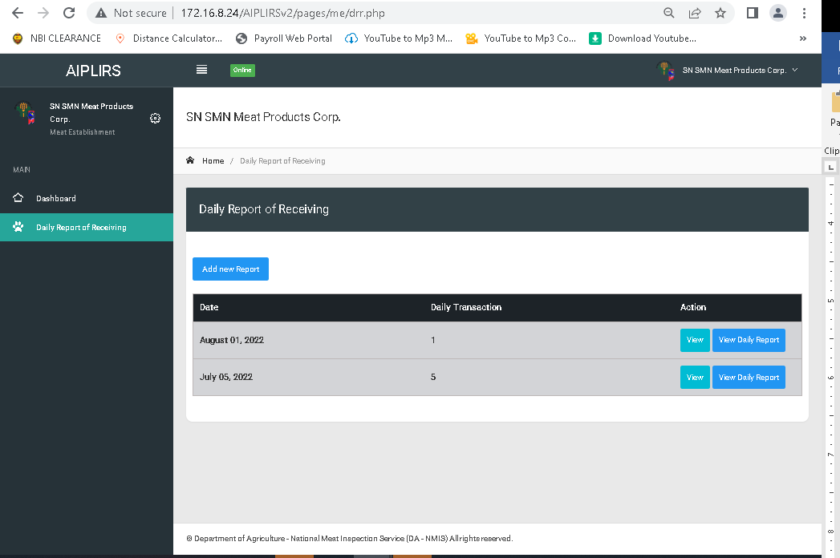

List of transaction same with sidebar

August 23, 2022

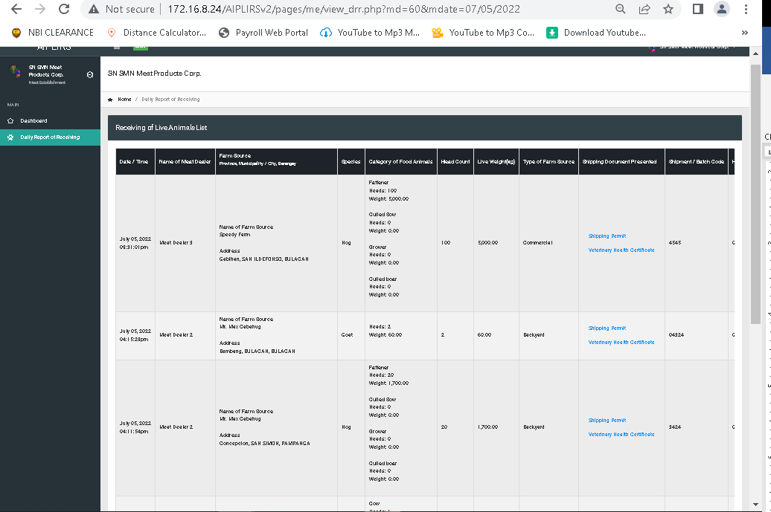

Same pattern in MIO “Daily receiving of animals” important details: drr status , Inspection status

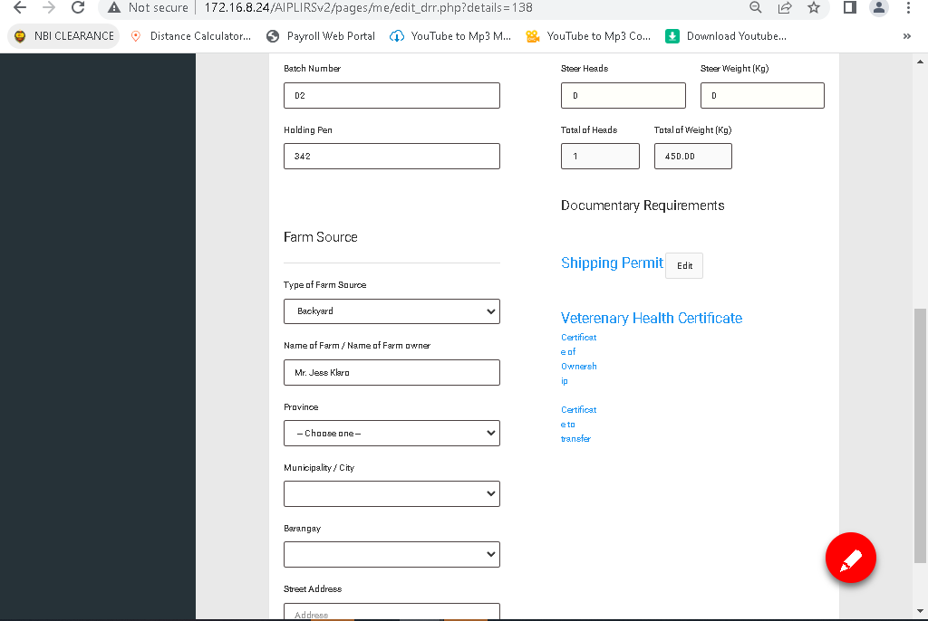

Change edit icon to word “Submit”

Spelling of Veterinary certificate

Change font of the LINK for certificate of ownership, transfer

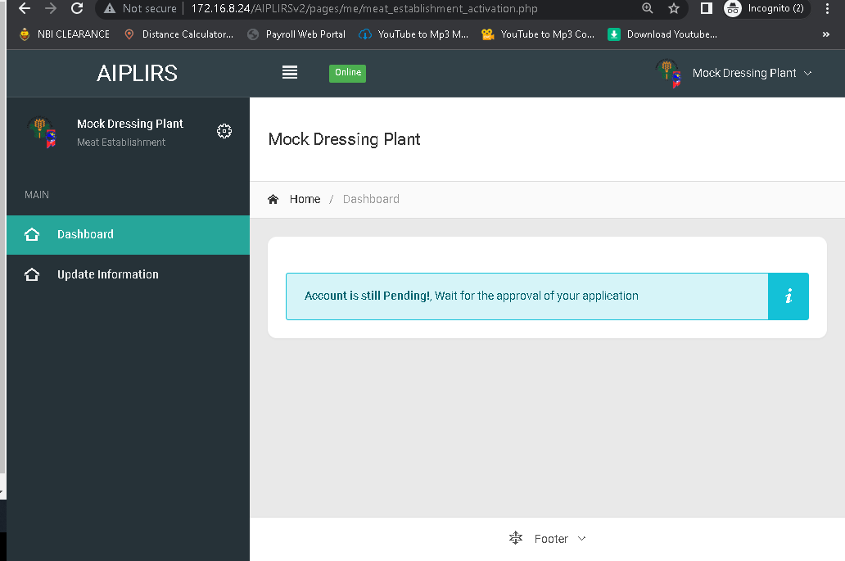

Your account is still pending.

Please wait for the approval of your account make it center